



ADSE-I

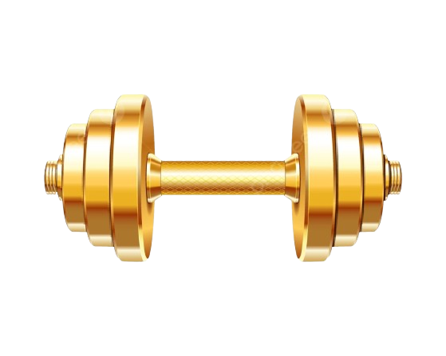Fitness Tracker

* **GROUP MEMBERS NAMES**
  + - RABIA KANWAL ( 1421223 )
    - SHAIKH MINHAJ UDDIN ( 1398610 )
    - FILZA ( 1455894 )
    - TOOBA TARIQ ( 1419863 )

**User Guide**

**SIGN UP PAGE:**

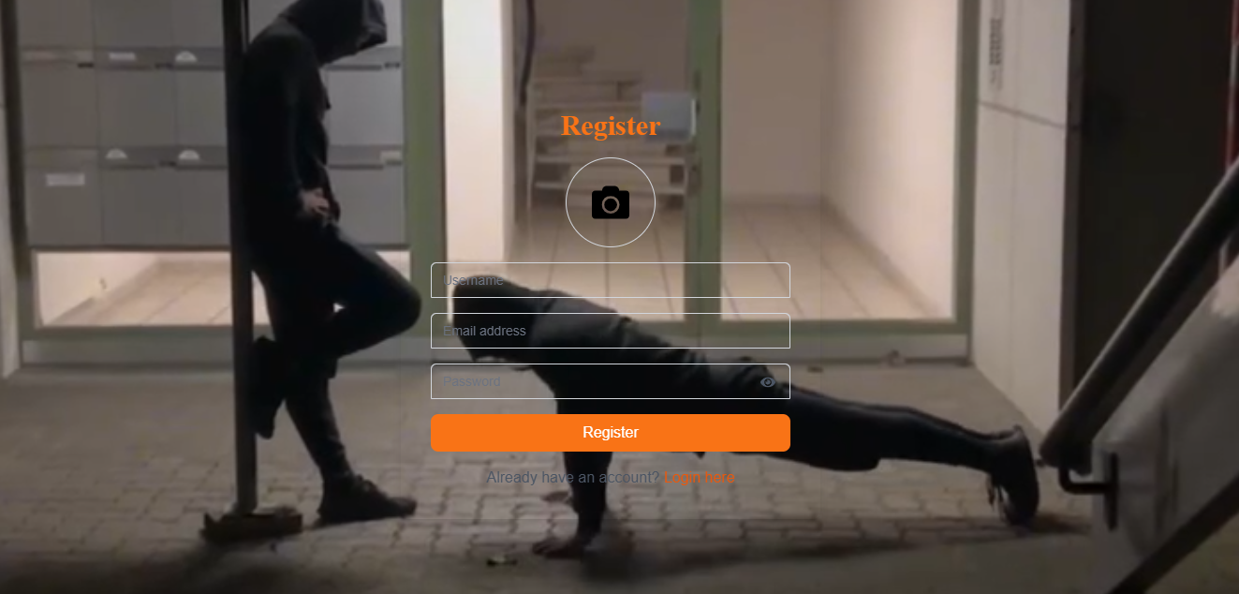

**LOGIN PAGE:**

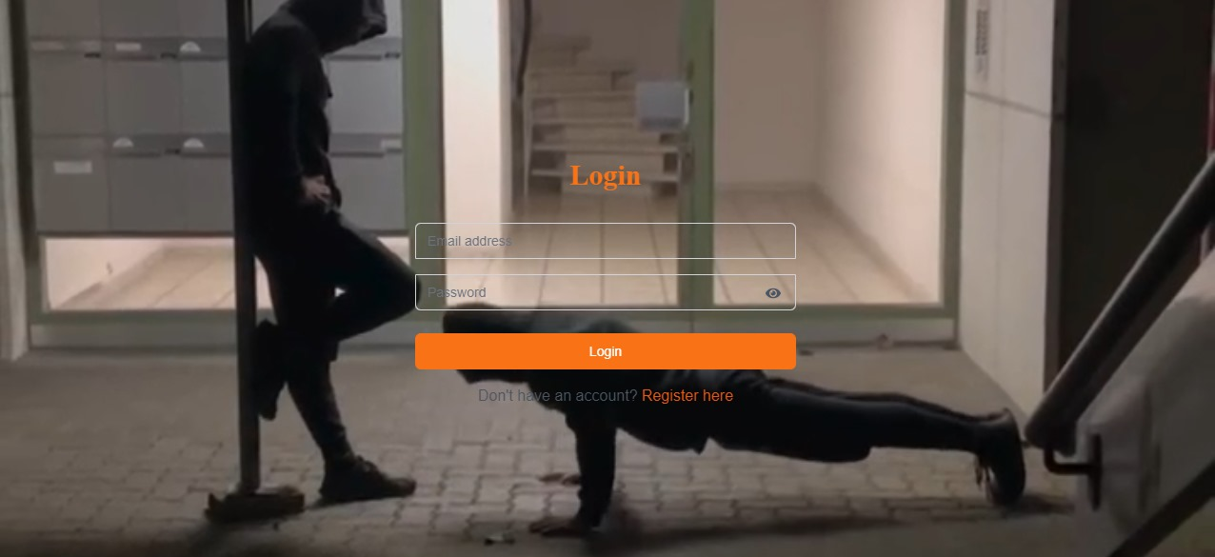

**HOME PAGE:**

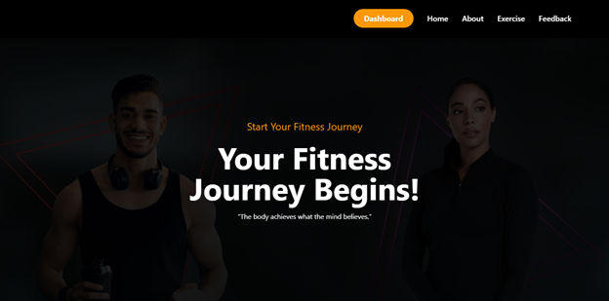

**ABOUT PAGE:**

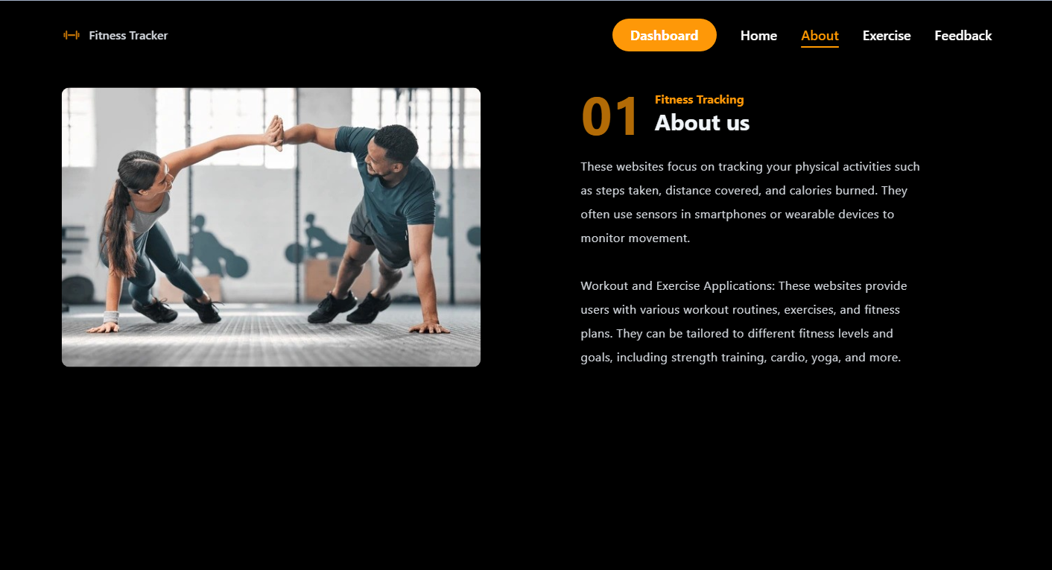

**EXERCISE PAGE:**

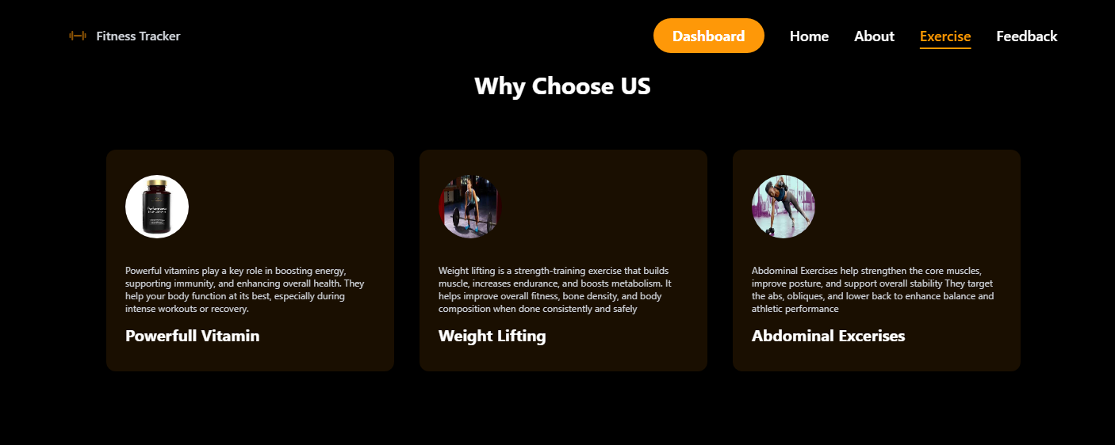

**BLOG PAGE:**

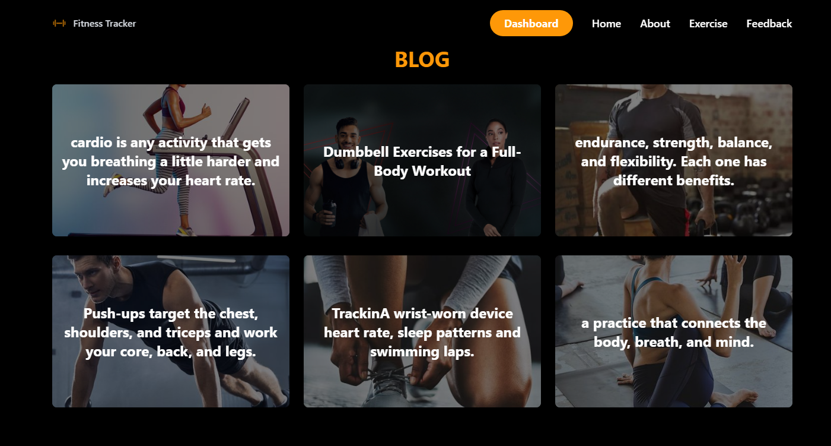

**FEEDBACK PAGE:**

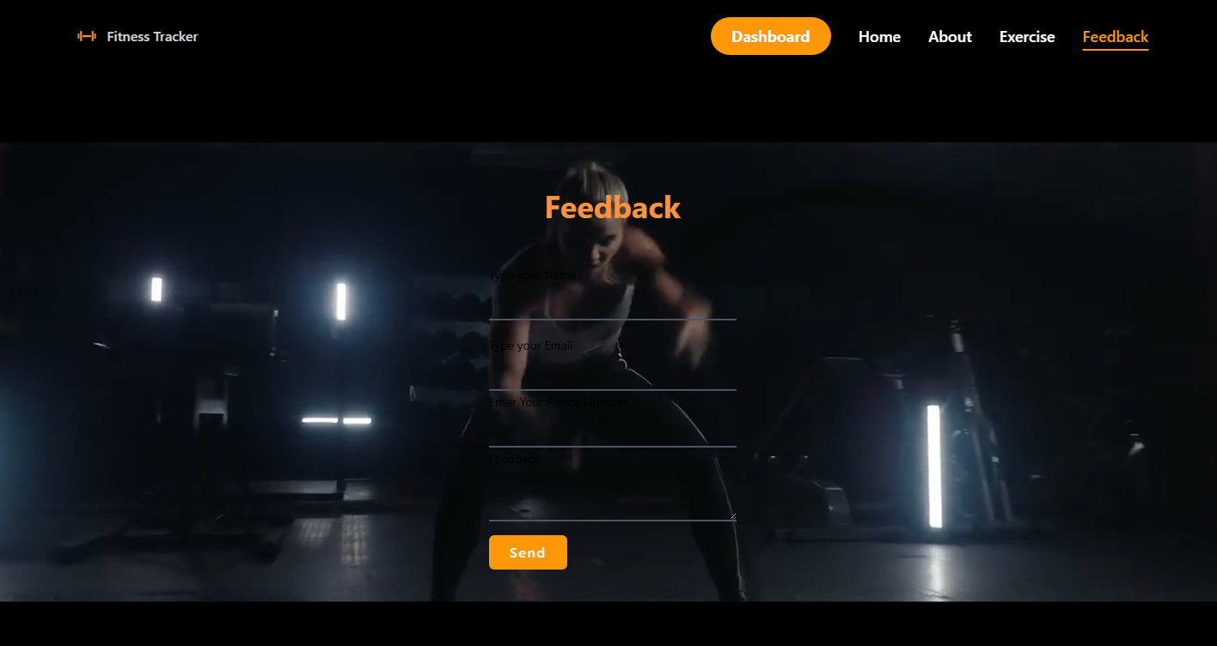

**FOOTER**

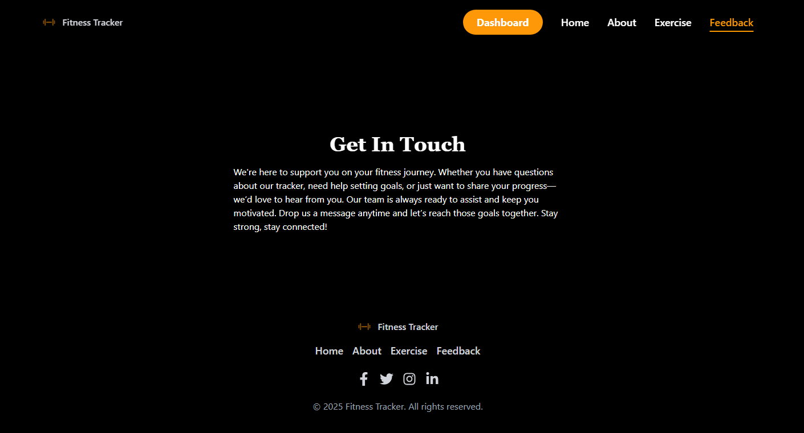

**USER DASHBOARD**

**USER PROFILE:**

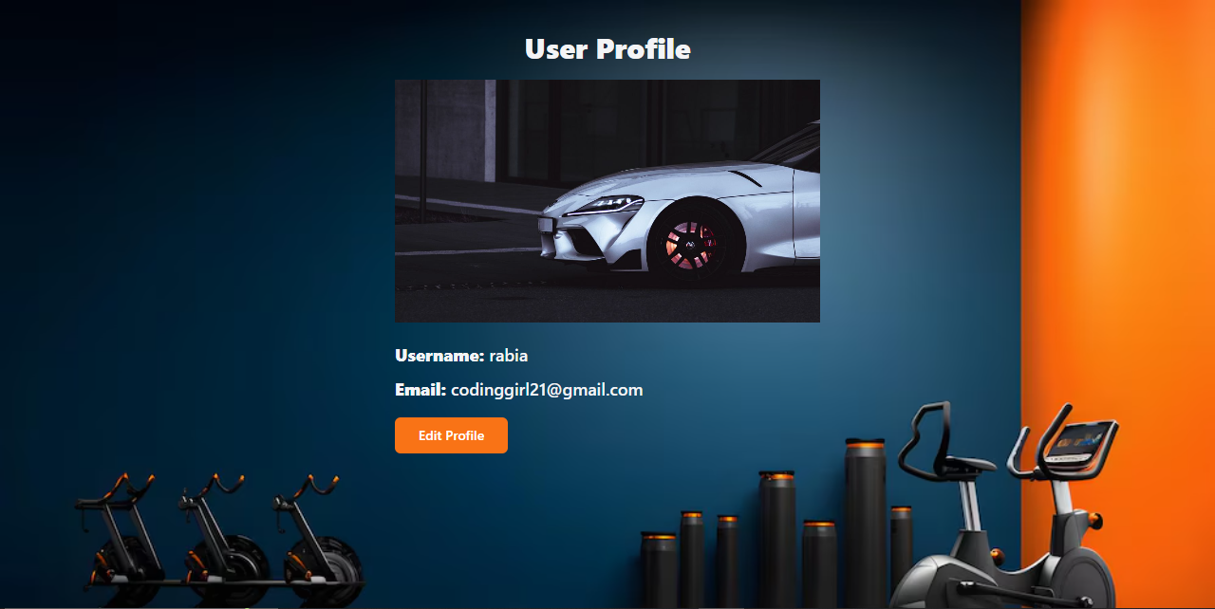

**UPDATE USER PROFILE:**

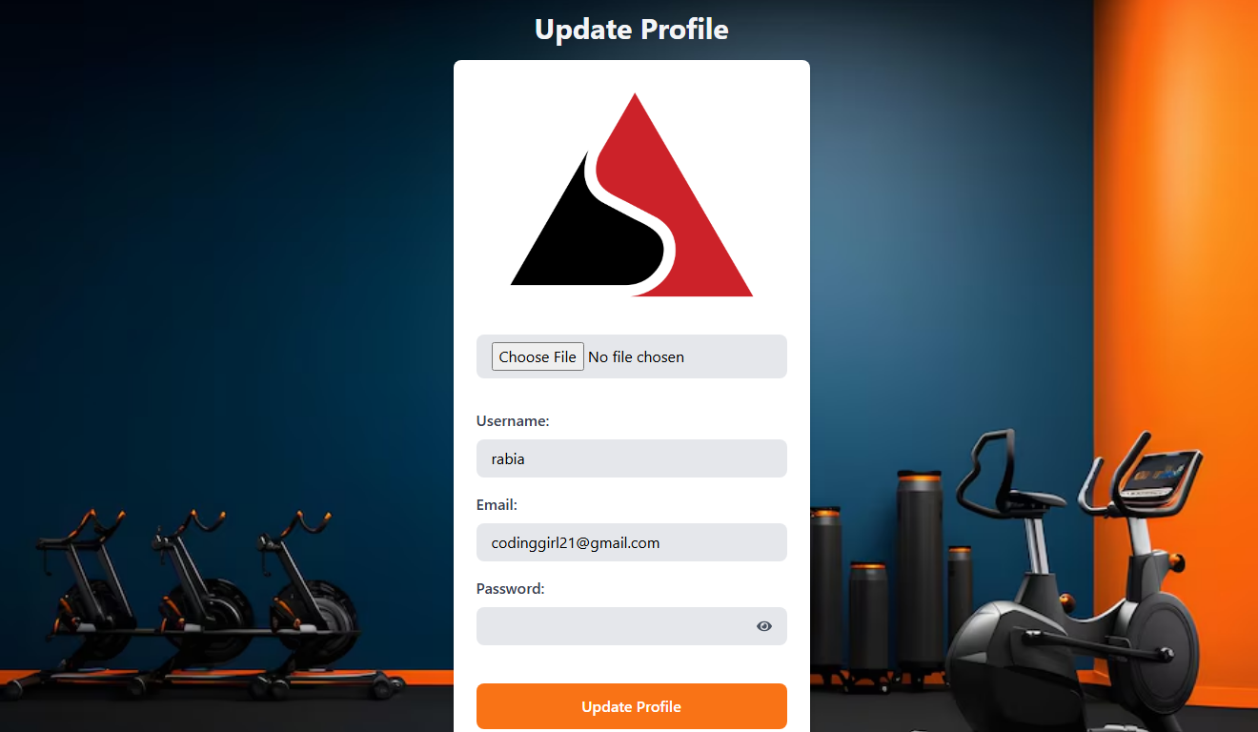

**DASHBOARD:**

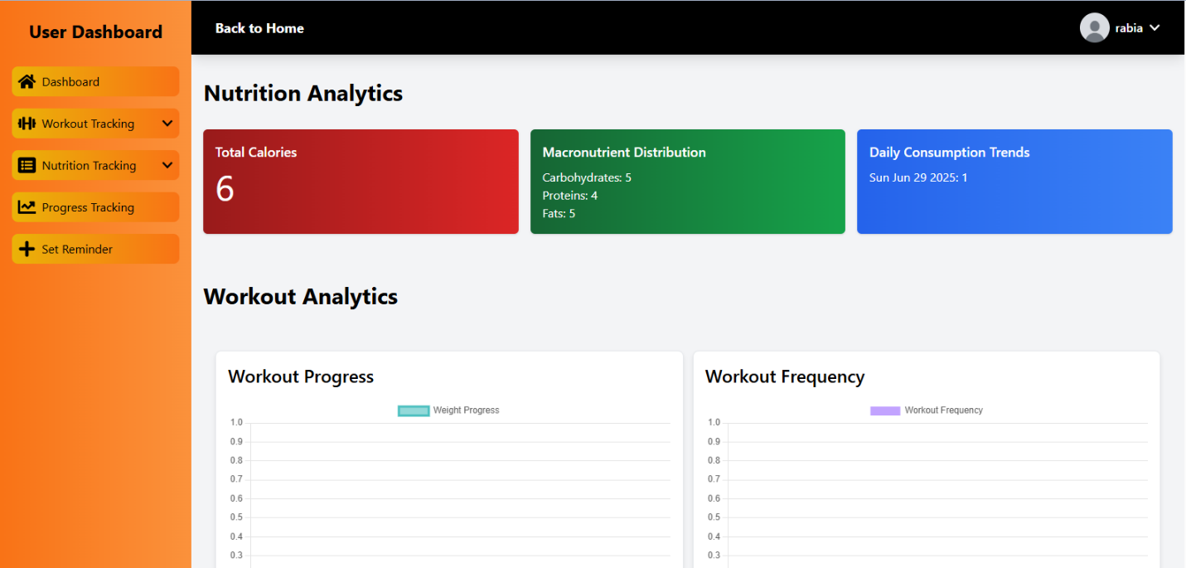

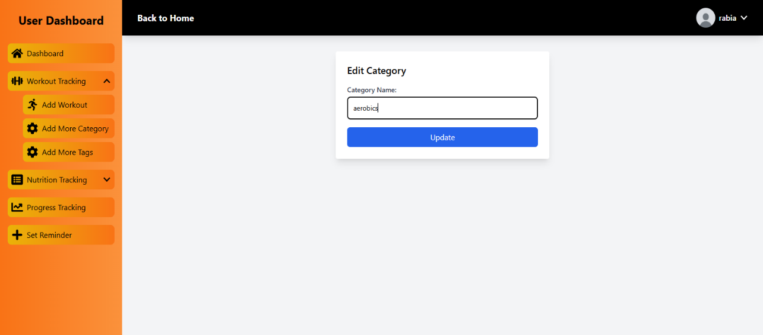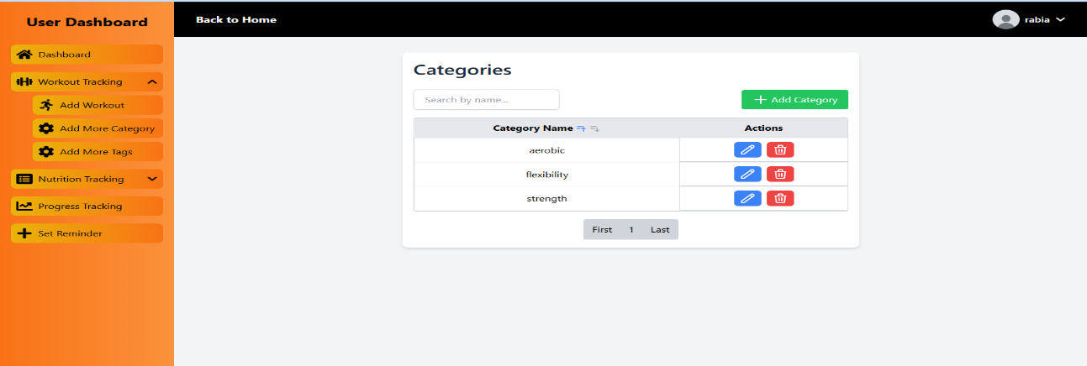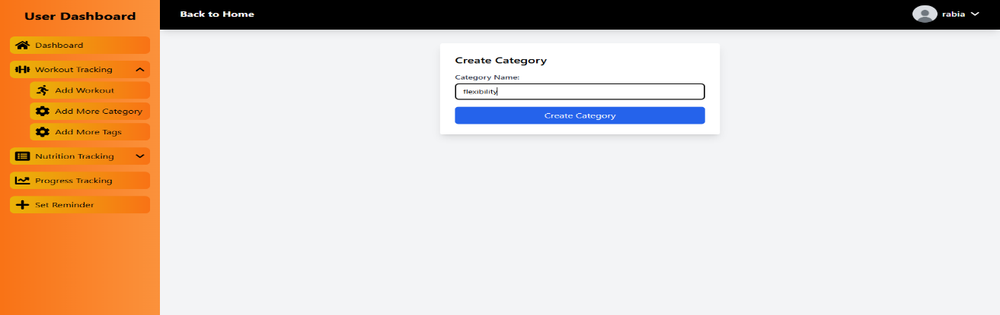**ADD MORE CATEGORY:**

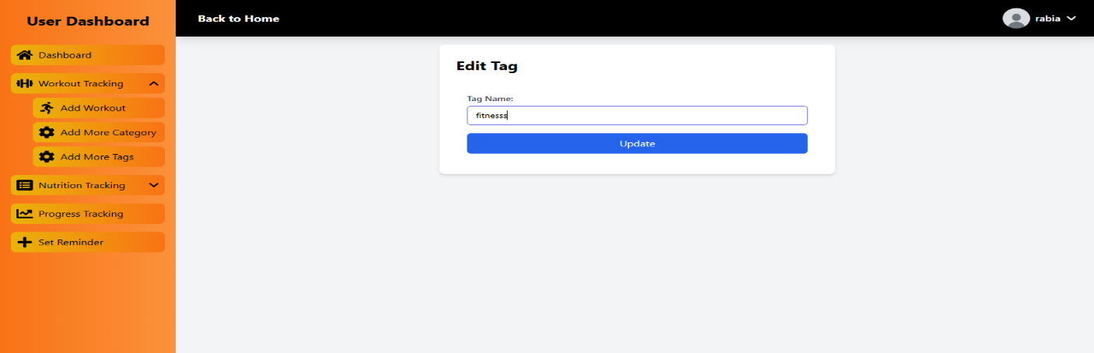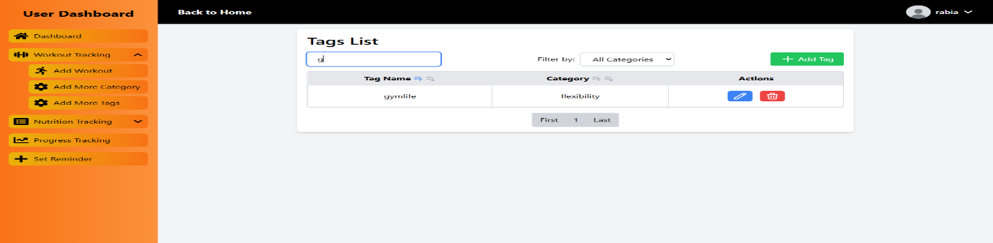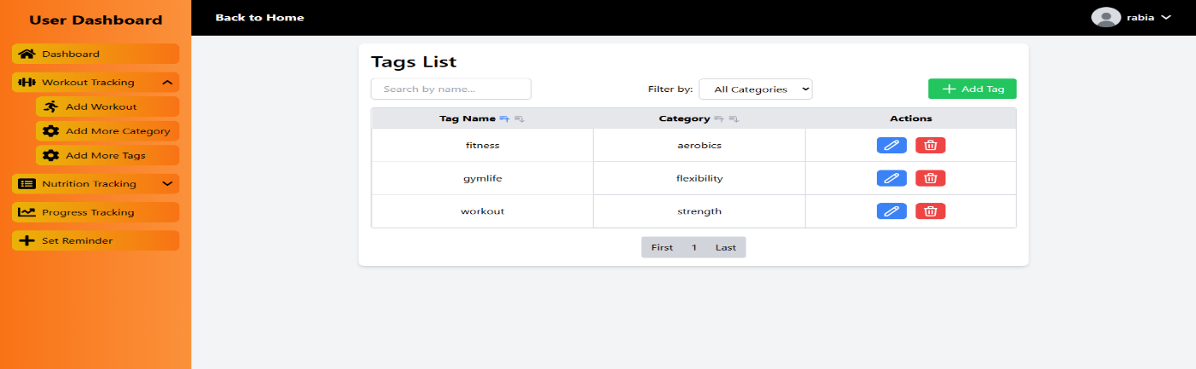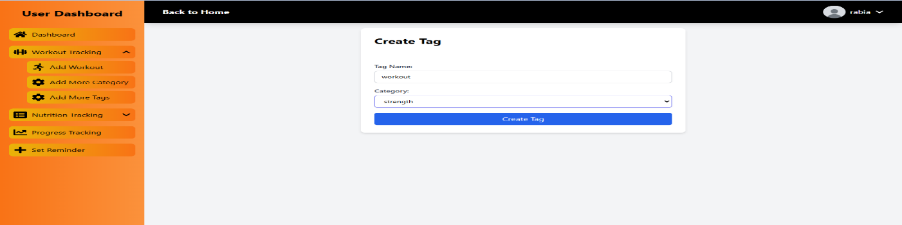**ADD MORE TAGS:**

**ADD WORKOUT:**

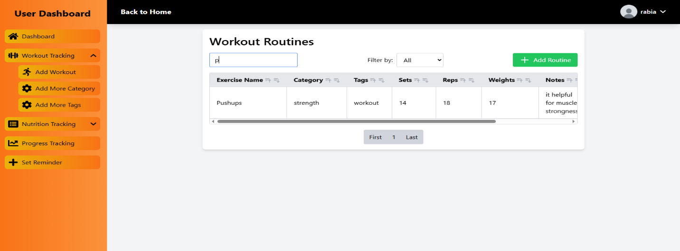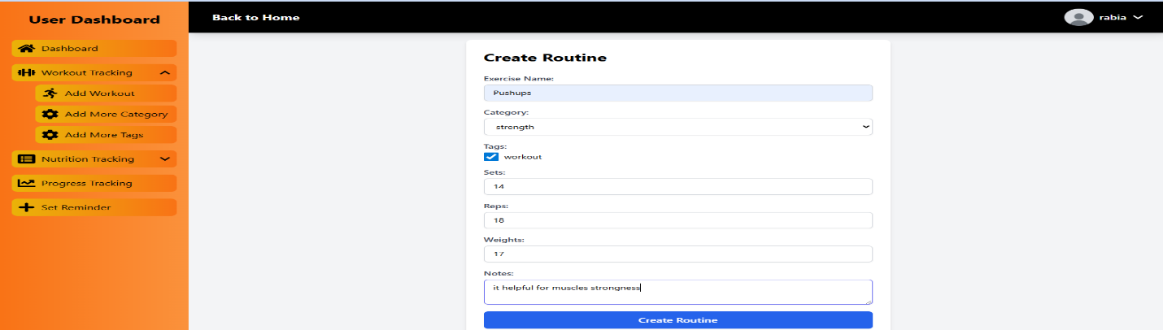

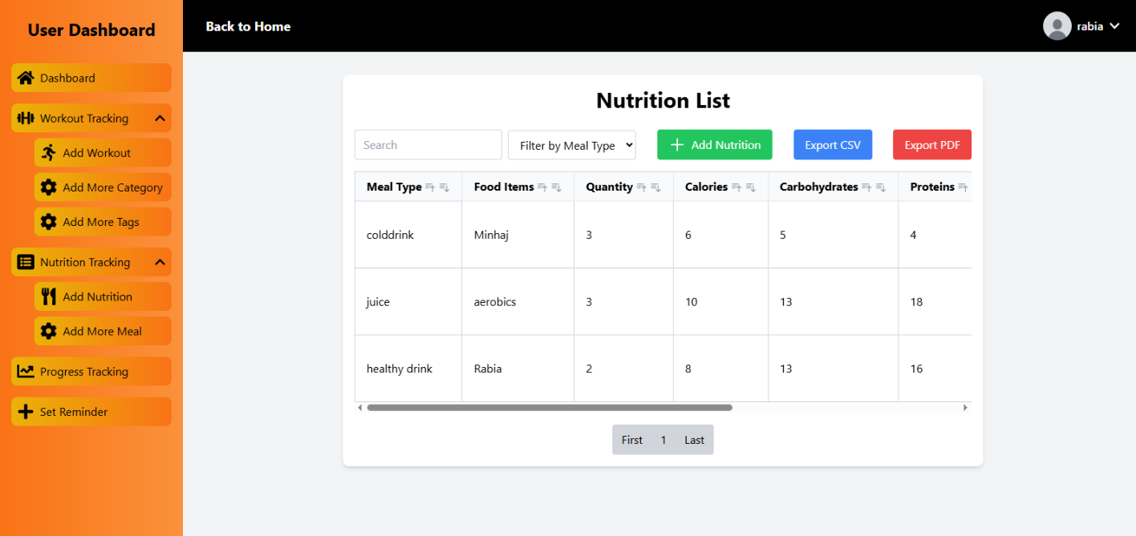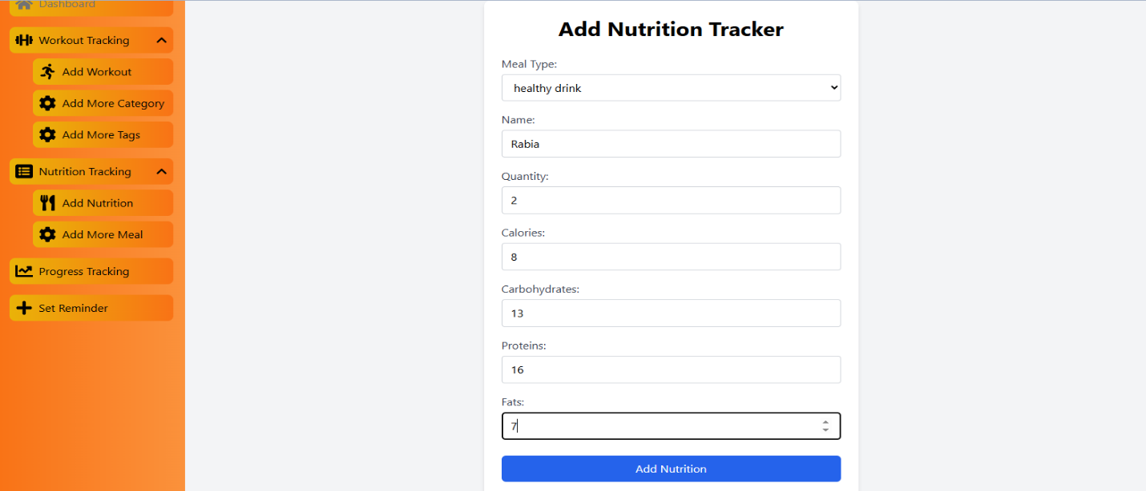**ADD NUTRITION:**

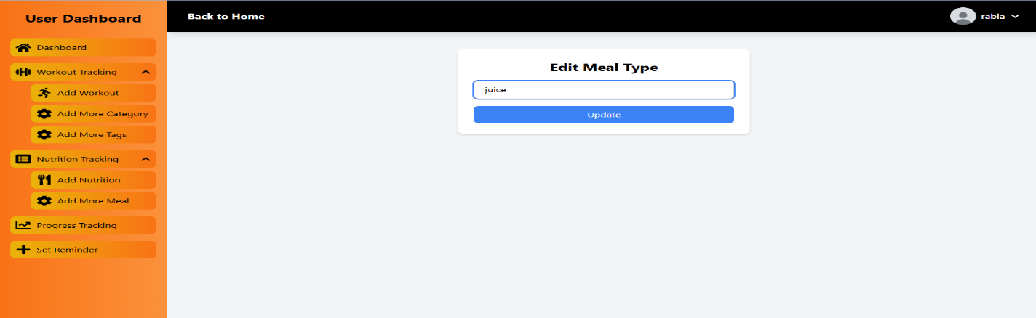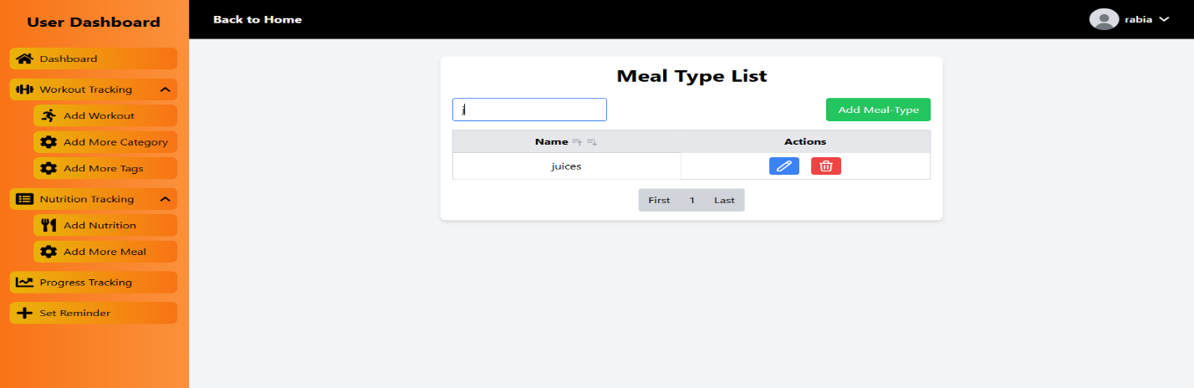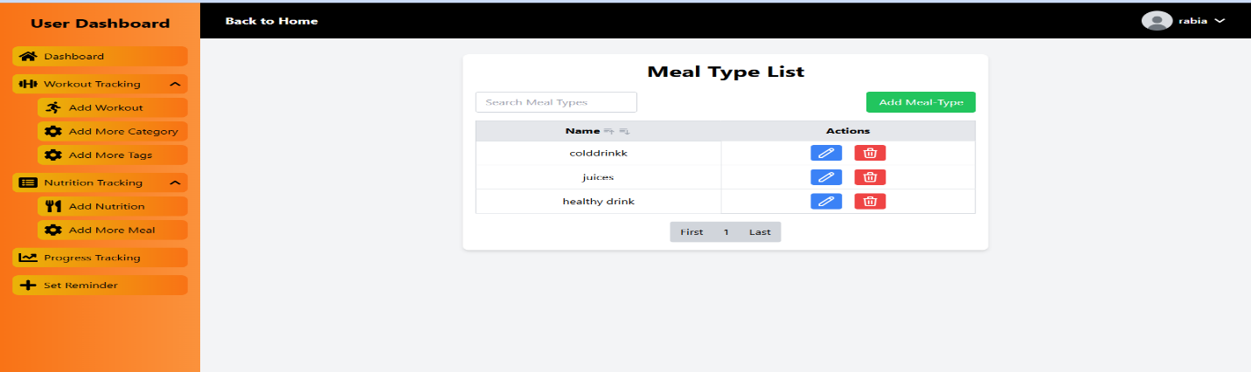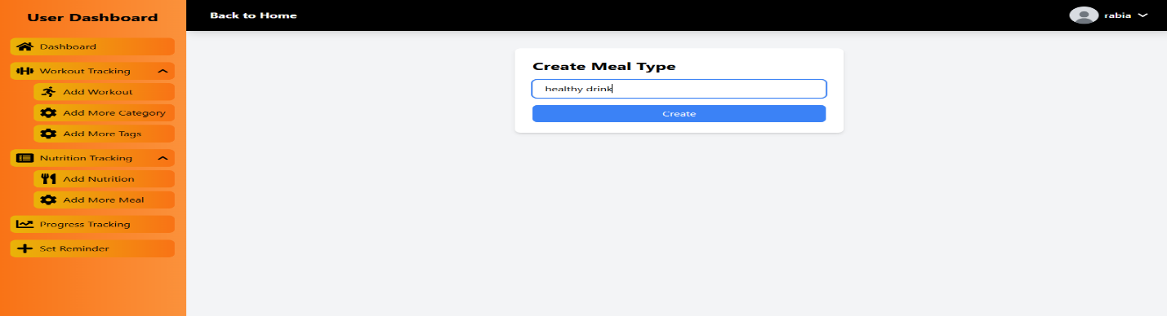**ADD MEAL TYPE:**

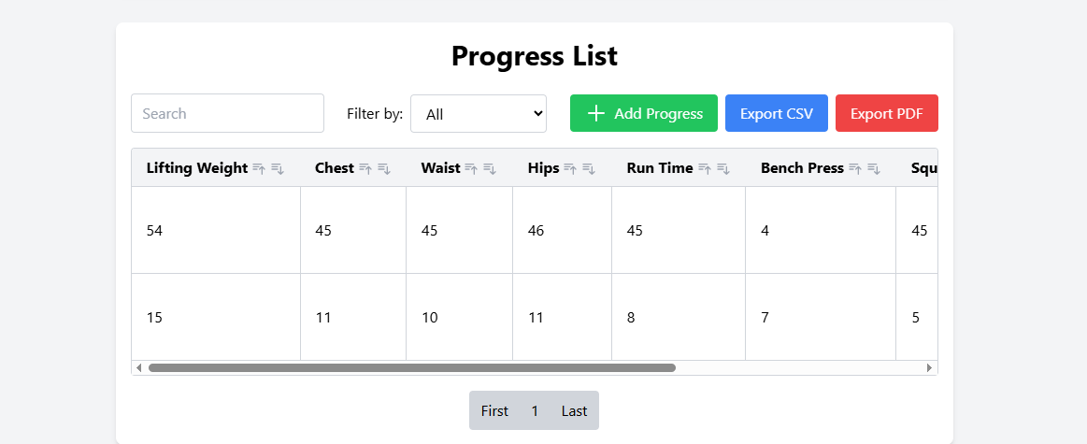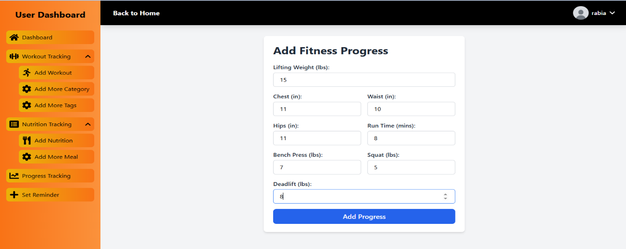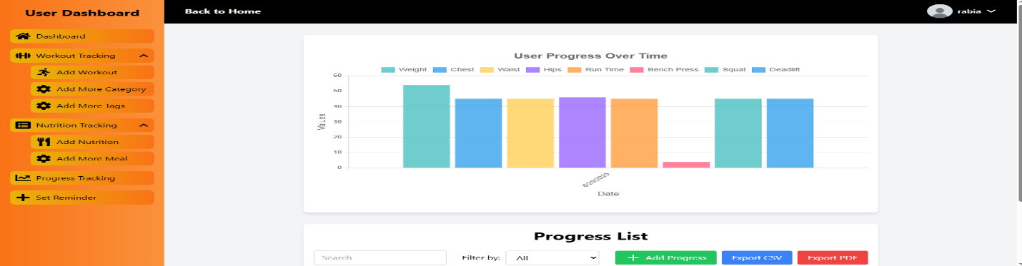**PROGRESS TRACKING:**

**SET REMAINDER:**

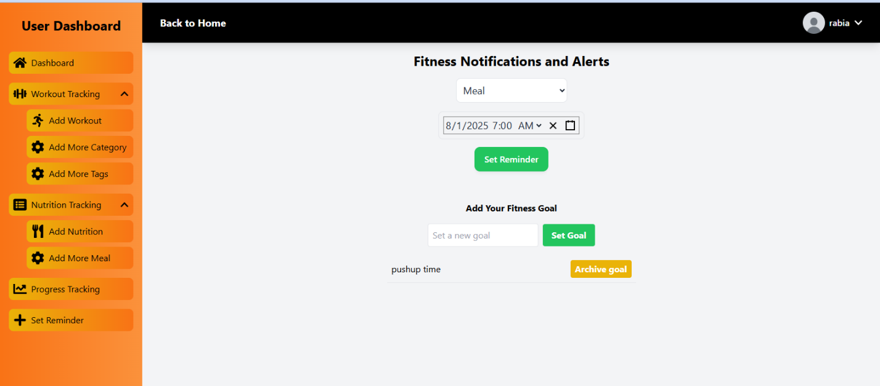

**User Guide SUMMARY**

* The **Fitness Tracker User Guide** is a comprehensive resource designed to help users navigate and make the most of their experience on the Fitness Tracker platform. The guide covers everything from account setup to tracking workouts and monitoring progress, ensuring a seamless and rewarding fitness journey.
* It begins with an overview of the Fitness Tracker platform and its purpose as a centralized tool for health and wellness, offering features like activity tracking, workout logging, goal setting, and performance analysis. The guide then walks users through the registration and login process, including how to create an account, log in securely, and manage personal health data and preferences.
* Users will find detailed instructions on how to explore the dashboard, start tracking daily activities (such as steps, calories burned, and heart rate), and view progress over time. The guide also covers how to create or follow workout plans, log exercises, and set personalized fitness goals.
* Additionally, the guide explains how to view workout history and performance trends, helping users monitor their progress in real-time. It also includes information on community features like sharing achievements, participating in fitness challenges, and offering feedback on the platform.
* Overall, the **Fitness Tracker User Guide** ensures an intuitive and user-friendly experience, empowering users to stay motivated, track their health, and achieve their fitness goals effectively.

